**4. FREQUENCY RESPONSE OF COMMON SOURCE FET AMPLIFIER**

**AIM:**

1. To obtain the Frequency response characteristics of Common Source FET amplifier.
2. To determine the Bandwidth.

**APPARATUS:**

|  |  |  |  |  |
| --- | --- | --- | --- | --- |
| S.No | Apparatus | Type | Range | Quantity |
| 01 | N-Channel FET | BFW10 |  | 01 |
| 02 | Resistance |  | (6.8KΩ, 1MΩ, 1.5KΩ) | 01 |
| 03 | Regulated Power supply |  | (0-30V) | 01 |
| 06 | Capacitor |  | (0.1µF, 0.1µF, 47µF) | 01 |
| 07 | Signal Generator |  | 10-1M Hz | 01 |
| 08 | CRO |  |  | 01 |
| 09 | Breadboard and Wires ,CRO  Probes |  |  |  |

**CIRCUIT DIAGRAM:**

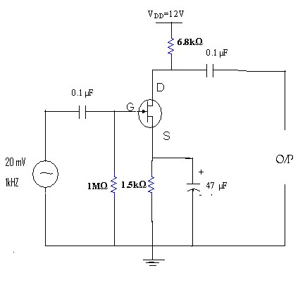

**PROCEDURE:**

1. Connections are made as per the circuit diagram.
2. A 10V supply is given to the circuit.
3. A certain amplitude of input signal (say 20mv at 1 kHz) is kept constant using signal generator and for different frequencies, the output voltage (V0) is taken at Drain from CRO .

# *V*0

1. Gain of the amplifier is calculated using *Gain*(*dB*)  20log Where Vo is output voltage, *Vi*

Vi is input voltage.

1. Plot the graph between Gain in dB and frequency.

**CALCULATION:**

1. Input Frequency = 100 Hz

Output Voltage (Vo) = 176.527 mV

Input Voltage (Vin) = 14.412 mV

So , Voltage gain = Vo/Vin **=** 176.527mV/14.412mV

= 12.249

Gain (dB) = 20 log Vo/Vin = 20 log (8.340)

= 21.76

1. Input Frequency = 1 kHz

Output Voltage (Vo) = 26.791 mV

Input Voltage (Vin) = 14.412 mV

So , Voltage gain = Vo/Vin **=** 26.791mV/14.412mV

= 1.858

Gain (dB) = 20 log Vo/Vin = 20 log (1.858)

= 5.4

1. Input Frequency = 1 MHz

Output Voltage (Vo) = 177.049 mV

Input Voltage (Vin) = 14.412 mV

So , Voltage gain = Vo/Vin **=** 177.049mV/14.412mV

= 12.285

Gain (dB) = 20 log Vo/Vin = 20 log (0.0821)

= 21.8

Bandwidth = f**high –** f**low** = 31.1562 MHz – 8.3482 Hz = 31.1562 MHz

**TABULAR COLUMN: Vin= 14.412 mV**

|  |  |  |  |  |
| --- | --- | --- | --- | --- |
| S.no. | Input frequency (Hz) | O/p voltage(VO)  (mv) | voltage gain  *V*  Av= 0  *Vi* | *V*  *Gain*(*dB*)  20log 0  *Vi* |
|  | 100Hz  1 KHz  1 MHz | 176.527 mV  26.791 mV  177.049 mV | 12.249  1.858  12.285 | 21.76  5.4  21.8 |

# **Model Graph**

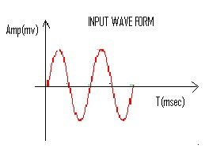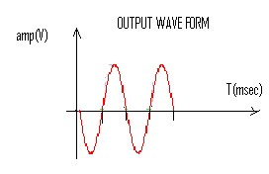

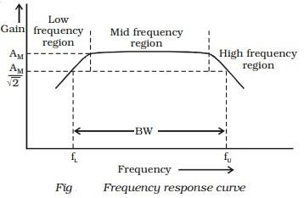

**Calculations from Graph**

1.Draw a line at maximum gain(dB) less than by 3dB parallel to the X-axis as shown in the figure

2.Draw two lines at the intersection of the characteristic curve and the 3dB line onto the X-axis which gives the (fH) and (fL)

3.The difference between fH and fL gives the Bandwidth of the amplifier.

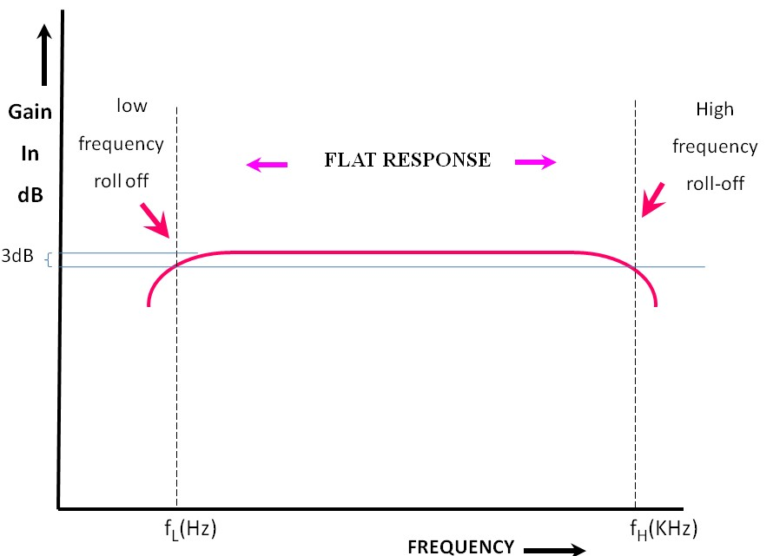

**OBSERVATION:**

CIRCUIT DIAGRAM

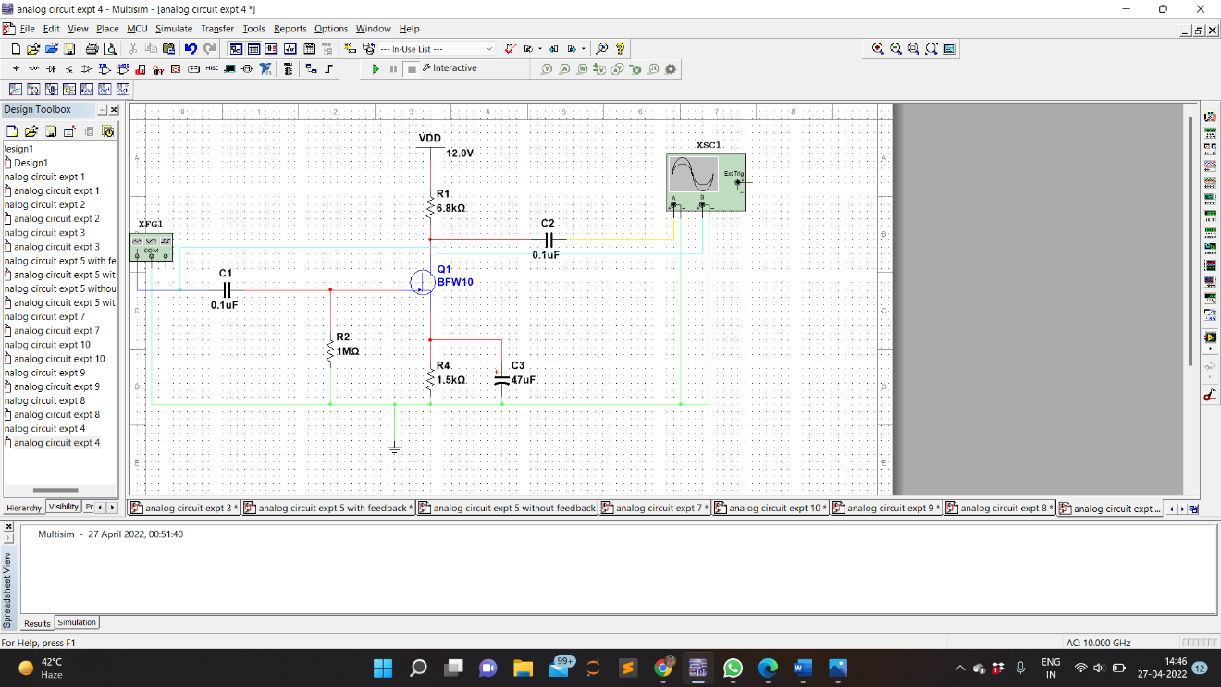

WAVEFORM

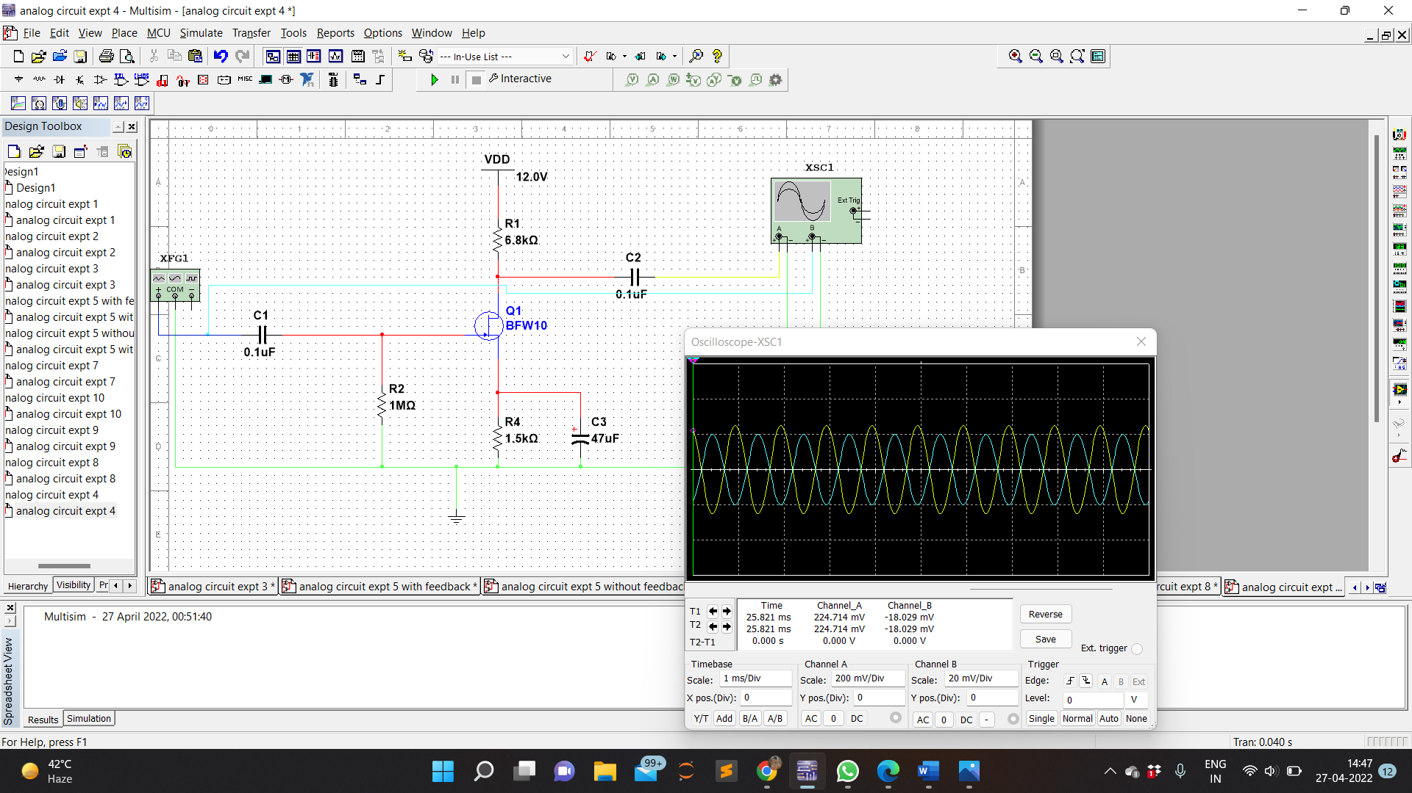

OUTPUT VOLTAGE

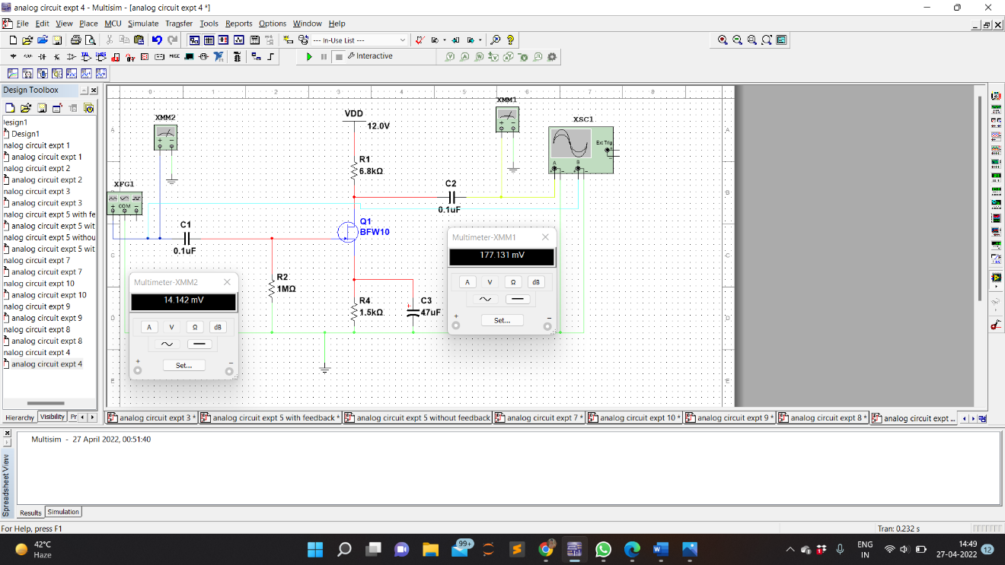

BANDWIDTH

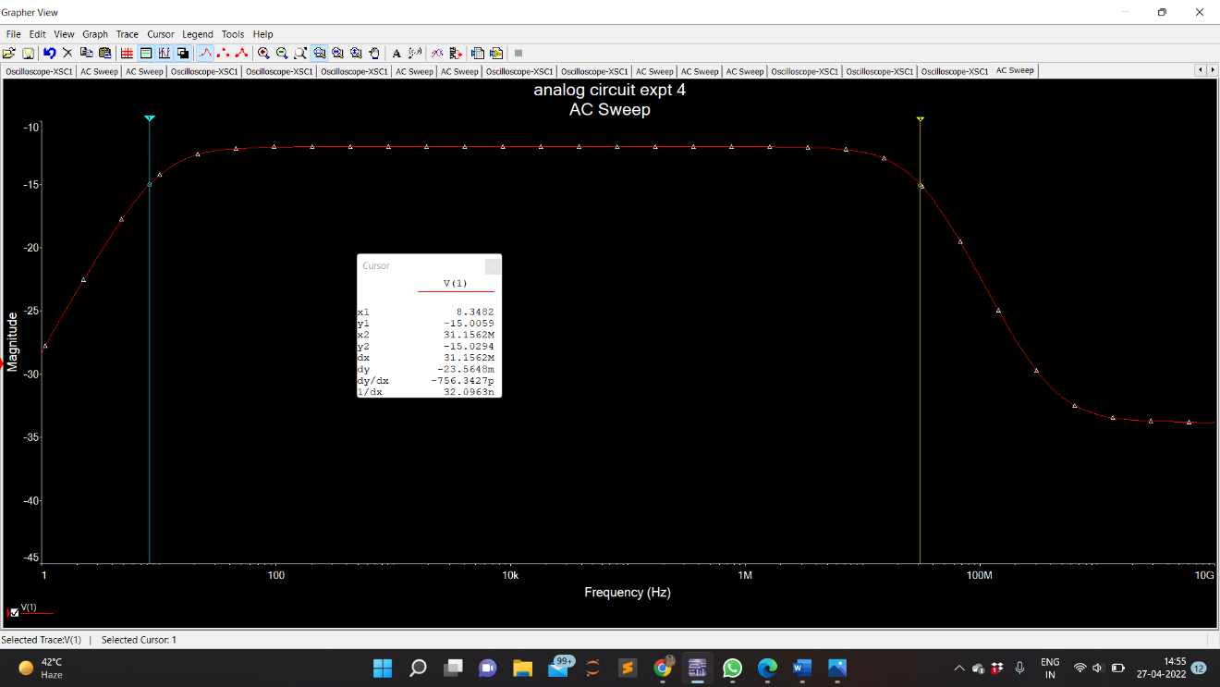

**PRECAUTIONS:**

1. While doing the experiment do not exceed the ratings of the transistor. This may lead to damage of the transistor.
2. Do not switch **ON** the power supply unless you have checked the circuit connections as per the circuit diagram.
3. Transistor terminals must be identified properly.

**RESULT:**

The frequency response of common source FET amplifier is observed and the bandwidth of the amplifier is calculated throught the circuit designed.